**µA 741 OPERATIONAL AMPLIFIER**

An **operational amplifier** (op-amp) is a [DC](http://en.wikipedia.org/wiki/Direct_current)-[coupled](http://en.wikipedia.org/wiki/Direct_coupling) high-[gain](http://en.wikipedia.org/wiki/Gain) electronic voltage [amplifier](http://en.wikipedia.org/wiki/Electronic_amplifier) with a [differential input](http://en.wikipedia.org/wiki/Differential_input) and, usually, a single-ended output. An op-amp produces an output voltage that is typically hundreds of thousands of times larger than the voltage *difference* between its input terminals.

An op-amp without negative feedback (a comparator)

* The amplifier's differential inputs consist of a *V*+ input and a *V*− input, and ideally the op-amp amplifies only the difference in voltage between the two, which is called the *differential input voltage.*

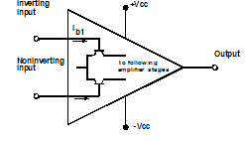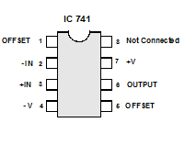

**OperationalampifierIC741.**

* where *V*+ is the voltage at the non-inverting terminal, *V*− is the voltage at the inverting terminal and *A*OL is the [open-loop](http://en.wikipedia.org/wiki/Electronic_feedback_loops) gain of the amplifier (the term "open-loop" refers to the absence of a feedback loop from the output to the input).